 

**Faculty of Computers and Artificial Intelligence**

**Cairo University**

**Final Assessment Project**

**Course Title: Introduction to Database Systems (IS211)**

**Semester: Second Semester Date: May 2020**

**Instructors: Dr. Iman Hassan & Dr. Amani Hassan**

Transportation System Project

**Prepared by:**

|  |  |
| --- | --- |
| Student Name | Student ID |
| Rawda Ahmed Mohamed Abdullah | 20180108 |
| Abdulrahman Hassan Elsayed Hassan | 20180141 |
| Moamen Ali Soliman Hamada | 20180298 |
| Ahmed Mohamed Ibrahem Abdelnaby | 20180021 |
| Sara Atef Mazhar Ibrahem | 20180117 |

**Contents**

**Chapter 1: Introduction**

The introduction should give the reader the appropriate knowledge and background to understand the project. Make your purpose known and introduce your topic. Explain why the project idea is important to readers.

The introduction should contain the following information:

* **Description of the project idea**

Describe the idea behind the project

* **Technology and tools used**

Microsoft SQL Server 2013 Management Studio.

<https://erdplus.com/standalone>

**Chapter 2: Analysis**

* **DB Conceptual ERD**

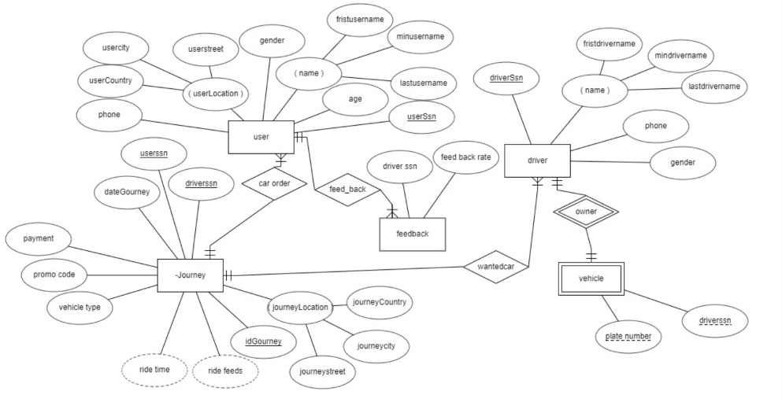

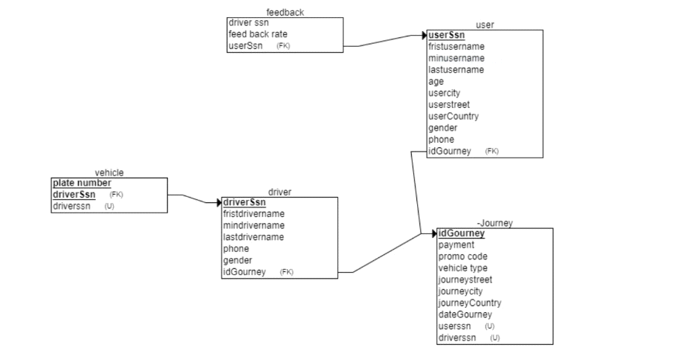

* **DB Physical ERD**

### Create database

create database finalProject;

### Create tables

CREATE TABLE driverR

(

driverSsn INT NOT NULL,

fristdrivername VARCHAR(40) NOT NULL,

mindrivername VARCHAR(40) NOT NULL,

lastdrivername VARCHAR(40) NOT NULL,

phone INT NOT NULL,

gender varchar(20) NOT NULL,

PRIMARY KEY (driverSsn),

);

CREATE TABLE userR

(

fristusername VARCHAR(40) NOT NULL,

minusername VARCHAR(40) NOT NULL,

lastusername VARCHAR(40) NOT NULL,

age INT NOT NULL,

phone INT NOT NULL,

gender varchar(20) NOT NULL,

userSsn INT,

usercity VARCHAR(40) NOT NULL,

userstreet VARCHAR(40) NOT NULL,

userCountry VARCHAR(40) NOT NULL,

PRIMARY KEY (userSsn),

);

CREATE TABLE JourneyR

(

payment VARCHAR(40) NOT NULL,

promo_code INT NOT NULL,

vehicle_type VARCHAR(40) NOT NULL,

idJourney INT,

journeystreet VARCHAR(40) NOT NULL,

journeycity VARCHAR(40) NOT NULL,

journeyCountry VARCHAR(40) NOT NULL,

--ReservationTime VARCHAR(40),

orderDate DATETIME NOT NULL,

driverID INT,

userSsn INT,

PRIMARY KEY (idJourney,userSsn),

FOREIGN KEY (userSsn) REFERENCES UserR(userSsn)

);

--To check the vehicle type

alter table JourneyR

add constraint ck_vehicle_type15 check (vehicle_type IN('car','bus','scooter'));

--To check the way of payment

alter table JourneyR

add constraint ck_payment15 check (payment IN('Cash','Visa','MasterCard'));

--Every driver has only one vehicle and they entered it in this db

CREATE TABLE vehicleR

(

vehicle_type VARCHAR(40) NOT NULL,

plate_number INT,

driverSsn INT,

PRIMARY KEY (plate_number,driverSsn),

FOREIGN KEY (driverSsn) REFERENCES driverR(driverSsn)

);

CREATE TABLE Journey_feed_backR

(

driverSsn INT,

userSsn INT,

rateOfFeedBack FLOAT NOT NULL,

PRIMARY KEY(userSsn),

FOREIGN KEY (userSsn) REFERENCES userR(userSsn)

);

Set Data

--insert values in driver table

insert into driverR (driverSsn , fristdrivername , mindrivername , lastdrivername , phone , gender)

values (11 , 'ali' , 'ramzi' , 'hani' , 01145618947 , 'male');

insert into driverR (driverSsn , fristdrivername , mindrivername , lastdrivername , phone , gender)

values (12 , 'samy' , 'glal' , 'nagm' , 01110025899 , 'male');

insert into driverR (driverSsn , fristdrivername , mindrivername , lastdrivername , phone , gender)

values (13 , 'ezat' , 'saad' , 'ezat' , 01171433011 , 'male');

insert into driverR (driverSsn , fristdrivername , mindrivername , lastdrivername , phone , gender)

values (14 , 'samar' , 'ali' , 'tawfek' , 01179002355 , 'female');

insert into driverR (driverSsn , fristdrivername , mindrivername , lastdrivername , phone , gender)

values (15 , 'salma' , 'mohammed' , 'abutaleb' , 01131152800 , 'female');

insert into driverR (driverSsn , fristdrivername , mindrivername , lastdrivername , phone , gender)

values (16 , 'saly' , 'waleed' , 'ahmed' , 01178896615 , 'female');

insert into driverR (driverSsn , fristdrivername , mindrivername , lastdrivername , phone , gender)

values (17 , 'rahaf' , 'metwaly' , 'khalifa' , 01158912385 , 'female');

insert into driverR (driverSsn , fristdrivername , mindrivername , lastdrivername , phone , gender)

values (18 , 'salwa' , 'saed' , 'ragab' , 01111228815 , 'female');

insert into driverR (driverSsn , fristdrivername , mindrivername , lastdrivername , phone , gender )

values (19 , 'amgad' , 'selim' , 'ragab' , 01110096991 , 'male');

insert into driverR (driverSsn , fristdrivername , mindrivername , lastdrivername , phone , gender )

values (20 , 'murad' , 'ehab' , 'khalaf' , 01155112301 , 'male');

--insert values in user table

insert into UserR (fristusername , minusername , lastusername , age , gender , phone , userSsn , usercity , userstreet , userCountry)

values ('rana' , 'hussein' , 'ali' , 21 , 'female' , 01193612875 , 111 , 'cairo' , '15 tahreer street' , 'egypt')

insert into UserR (fristusername , minusername , lastusername , age , gender , phone , userSsn , usercity , userstreet , userCountry)

values ('hana' , 'salim' , 'soudy' , 18 , 'female' , 01125251232 , 112 , 'alexandria' , '9 elmofatesh street' , 'egypt')

insert into UserR (fristusername , minusername , lastusername , age , gender , phone , userSsn , usercity , userstreet , userCountry)

values ('ramy' , 'tarek' , 'yahia' , 31 , 'male' , 01121320019 , 113 , 'cairo' , '20 eldokki street' , 'egypt')

insert into UserR (fristusername , minusername , lastusername , age , gender , phone , userSsn , usercity , userstreet , userCountry)

values ('zain' , 'seif' , 'alam' , 43 , 'male' , 01123110078 , 114 , 'cairo' , '6 abas el3kad street' , 'egypt')

insert into UserR (fristusername , minusername , lastusername , age , gender , phone , userSsn , usercity , userstreet , userCountry)

values ('rawan' , 'hussein' , 'samy' , 28 , 'female' , 01125159753 , 115 , 'cairo' , '15 tahreer street' , 'egypt')

insert into UserR (fristusername , minusername , lastusername , age , gender , phone , userSsn , usercity , userstreet , userCountry)

values ('halim' , 'salim' , 'elmohamdy' , 20 , 'male' , 01125361478 , 116 , 'alexandria' , '916 elnozha street' , 'egypt')

insert into UserR (fristusername , minusername , lastusername , age , gender , phone , userSsn , usercity , userstreet , userCountry)

values ('remas' , 'medhat' , 'masour' , 50 , 'female' , 01132165412 , 117 , 'cairo' , '15 tahreer street' , 'egypt')

insert into UserR (fristusername , minusername , lastusername , age , gender , phone , userSsn , usercity , userstreet , userCountry)

values ('ziad' , 'ezz' , 'abdallah' , 19 , 'male' , 01136932165 , 118 , 'cairo' , '12 el3taba street' , 'egypt')

insert into UserR (fristusername , minusername , lastusername , age , gender , phone , userSsn , usercity , userstreet , userCountry)

values ('aliaa' , 'hamed' , 'zahy' , 21 , 'female' , 01269159710 , 119 , 'cairo' , '19 elgame3 street' , 'egypt')

insert into UserR (fristusername , minusername , lastusername , age , gender , phone , userSsn , usercity , userstreet , userCountry)

values ('sama' , 'ramy' , 'ayman' , 24 , 'female' , 01528971002 , 120 , 'cairo' , '8 elmo3ez street' , 'egypt')

insert into UserR (fristusername , minusername , lastusername , age , gender , phone , userSsn , usercity , userstreet , userCountry)

values ('rady' , 'mhana' , 'ezz' , 19 , 'male' , 01001233211 , 121 , 'cairo' , '17 elgame3 street' , 'egypt')

--insert values in journey table

insert into journeyR (payment , promo_code , vehicle_type , idJourney , journeystreet , journeycity , journeyCountry , orderDate , userSsn , driverID)

values ('MasterCard' , 30 , 'car' , 0 , '15 tahreer street' , 'cairo' , 'egypt' , '2020-3-14 17:00:00' , 111 , 13);

insert into journeyR (payment , promo_code , vehicle_type , idJourney , journeystreet , journeycity , journeyCountry , orderDate, userSsn , driverID)

values ('Cash' , 60 , 'bus' , 1 , '9 elmofatesh street' , 'alexandria' , 'egypt' , '2020-4-16 09:00:00' , 112 , 12);

insert into journeyR (payment , promo_code , vehicle_type , idJourney , journeystreet , journeycity , journeyCountry , orderDate, userSsn , driverID)

values ('Visa' , 20 , 'scooter' , 2 , '20 eldokki street' , 'cairo' , 'egypt' , '2020-2-7 13:30:00' , 113 , 11);

insert into journeyR (payment , promo_code , vehicle_type , idJourney , journeystreet , journeycity , journeyCountry , orderDate, userSsn , driverID)

values ('Cash' , 85 , 'car' , 3 , '6 abas elakad street' , 'cairo' , 'egypt' , '2020-4-9 21:00:00' , 114 , 13);

insert into journeyR (payment , promo_code , vehicle_type , idJourney , journeystreet , journeycity , journeyCountry , orderDate, userSsn , driverID)

values ('MasterCard' , 20 , 'bus' , 4 , '15 tahreer street' , 'cairo' , 'egypt' , '2020-5-10 17:30:00' , 115 , 18);

insert into journeyR (payment , promo_code , vehicle_type , idJourney , journeystreet , journeycity , journeyCountry , orderDate, userSsn , driverID)

values ('Cash' , 30 , 'bus' , 5 , '16 elnozha street' , 'alexandria' , 'egypt' , '2020-5-16 11:00:00' , 116 , 14);

insert into journeyR (payment , promo_code , vehicle_type , idJourney , journeystreet , journeycity , journeyCountry , orderDate, userSsn , driverID)

values ('Visa' , 90 , 'scooter' , 6 , '15 tahreer street' , 'cairo' , 'egypt' , '2020-4-20 18:30:00' , 117 , 16);

insert into journeyR (payment , promo_code , vehicle_type , idJourney , journeystreet , journeycity , journeyCountry , orderDate, userSsn , driverID)

values ('Cash' , 70 , 'car' , 7 , '12 elatba street' , 'cairo' , 'egypt' , '2020-4-11 12:00:00' , 118 , 13);

insert into journeyR (payment , promo_code , vehicle_type , idJourney , journeystreet , journeycity , journeyCountry , orderDate, userSsn , driverID)

values ('Visa' , 50 , 'car' , 8 , '12 elatba street' , 'cairo' , 'egypt' , '2020-7-13 14:00:00' , 119 , 15);

insert into journeyR (payment , promo_code , vehicle_type , idJourney , journeystreet , journeycity , journeyCountry , orderDate, userSsn , driverID)

values ('MasterCard' , 80 , 'bus' , 9 , '9 saad zaghlol street' , 'cairo' , 'egypt' , '2020-10-1 15:00:00' , 120 , 18);

insert into journeyR (payment , promo_code , vehicle_type , idJourney , journeystreet , journeycity , journeyCountry , orderDate, userSsn , driverID)

values ('Cash' , 67 , 'scooter' , 10 , '12 elatba street' , 'cairo' , 'egypt' , '2020-12-9 19:30:00' , 121 , 17);

--insert values in vehicle table

insert into vehicleR (vehicle_type , plate_number , driverSsn)

values ('scooter' , 121 , 11);

insert into vehicleR (vehicle_type , plate_number , driverSsn)

values ('bus' , 122 , 12);

insert into vehicleR (vehicle_type , plate_number , driverSsn)

values ('car' , 123 , 13);

insert into vehicleR (vehicle_type , plate_number , driverSsn)

values ('bus' , 124 , 14);

insert into vehicleR (vehicle_type , plate_number , driverSsn)

values ('car' , 125 , 15);

insert into vehicleR (vehicle_type , plate_number , driverSsn)

values ('scooter' , 126 , 16);

insert into vehicleR (vehicle_type , plate_number , driverSsn)

values ('scooter' , 127 , 17);

insert into vehicleR (vehicle_type , plate_number , driverSsn)

values ('bus' , 128 , 18);

insert into vehicleR (vehicle_type , plate_number , driverSsn)

values ('bus' , 129 , 19);

insert into vehicleR (vehicle_type , plate_number , driverSsn)

values ('car' , 130 , 20);

--insert values in Journey_feed_back table

insert into Journey_feed_backR (driverSsn , userSsn , rateOfFeedBack)

values(11 , 113 , 5)

insert into Journey_feed_backR (driverSsn , userSsn , rateOfFeedBack)

values(12 , 112 , 3)

insert into Journey_feed_backR (driverSsn , userSsn , rateOfFeedBack)

values(13 , 111 , 4)

insert into Journey_feed_backR (driverSsn , userSsn , rateOfFeedBack)

values(13 , 118 , 4.5)

insert into Journey_feed_backR (driverSsn , userSsn , rateOfFeedBack)

values(13 , 114 , 5)

insert into Journey_feed_backR (driverSsn , userSsn , rateOfFeedBack)

values(14 , 116 , 4.5)

insert into Journey_feed_backR (driverSsn , userSsn , rateOfFeedBack)

values(15 , 119 , 5)

insert into Journey_feed_backR (driverSsn , userSsn , rateOfFeedBack)

values(16 , 117 , 3)

insert into Journey_feed_backR (driverSsn , userSsn , rateOfFeedBack)

values(17 , 121 , 3.5)

insert into Journey_feed_backR (driverSsn , userSsn , rateOfFeedBack)

values(18 , 115 , 3)

insert into Journey_feed_backR (driverSsn , userSsn , rateOfFeedBack)

values(18 , 120 , 4.5)

# Chapter 3: SQL Queries + screenshots of the results

-------------------a)

--the area that had the most ride requests last month

select top(1) journeystreet+','+journeycity+','+journeyCountry as TheArea,COUNT(idJourney) as numberOfRideRequests_most

from JourneyR

Where Month(orderDate) =Month(getdate()) -1

group by journeystreet,journeycity ,journeyCountry

order by COUNT(idJourney) desc

--the area that had the least ride requests last month

select top(1) journeystreet+','+journeycity+','+journeyCountry as TheArea,COUNT(idJourney) as numberOfRideRequests_least

from JourneyR

Where Month(orderDate) =Month(getdate()) -1

group by journeystreet,journeycity ,journeyCountry

----------------------b)

--the drivers with the maximum number of rides last month

select distinct fristdrivername+' '+mindrivername+' '+lastdrivername as FullName,count(driverID) as numberOfRides

from driverR,JourneyR

where driverR.driverSsn=JourneyR.driverID

and Month(orderDate) =Month(getdate()) -1

group by driverSsn,fristdrivername,mindrivername,lastdrivername,phone

order by count(driverID) desc

----------------------c)

-- For each driver, retrieve all his/her information and the number of rides he/she had

select driverSsn,fristdrivername+' '+mindrivername+' '+lastdrivername as FullName,phone,count(driverID) as numberOfRides

from driverR left outer join JourneyR

on driverR.driverSsn=JourneyR.driverID

group by driverSsn,fristdrivername,mindrivername,lastdrivername,phone

---------------d)

-- drivers got at least 4.5 out of 5 on every user rating he/she got

--All drivers that got at least 4.5 out of 5 except the drivers that did not do any rides(they did not have any feedbacks)

select fristdrivername+' '+mindrivername+' '+lastdrivername as FullName

from driverR as d

where not exists (select *

from Journey_feed_backR as feedBack

where feedBack.driverSsn=d.driverSsn

and rateOfFeedBack < 4.5) except (select fristdrivername+' '+mindrivername+' '+lastdrivername as FullName

from driverR

except (select fristdrivername+' '+mindrivername+' '+lastdrivername as FullName

from driverR,journeyR

where driverR.driverSsn=journeyR.driverID));

----------------e)

--the drivers that didn’t have any ride last month

select fristdrivername+' '+mindrivername+' '+lastdrivername as FullName

from driverR

except (select fristdrivername+' '+mindrivername+' '+lastdrivername as FullName

from driverR,journeyR

where driverR.driverSsn=journeyR.driverID

and Month(orderDate) =Month(getdate()) -1);

----------------f)

-- the most type of vehicle (car, bus, and scooter) requested last month

select top(1) vehicle_type ,COUNT(vehicle_type) as numberOfRides

from JourneyR

where Month(orderDate) =Month(getdate()) -1

group by vehicle_type

order by numberOfRides desc

**References**

This section contains links or citations to any sources used in implementing and completing this project -if any